Slide 1

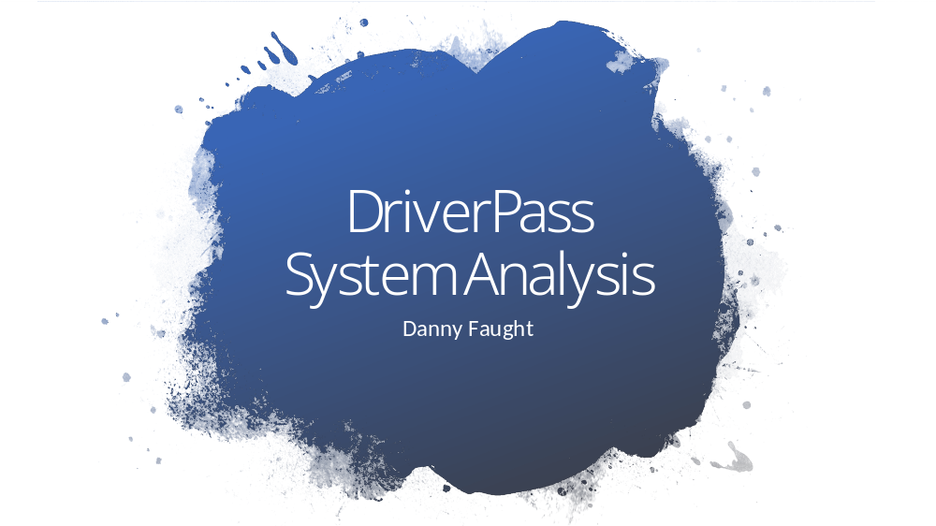

[No speaker notes required for this slide.]

Slide 2

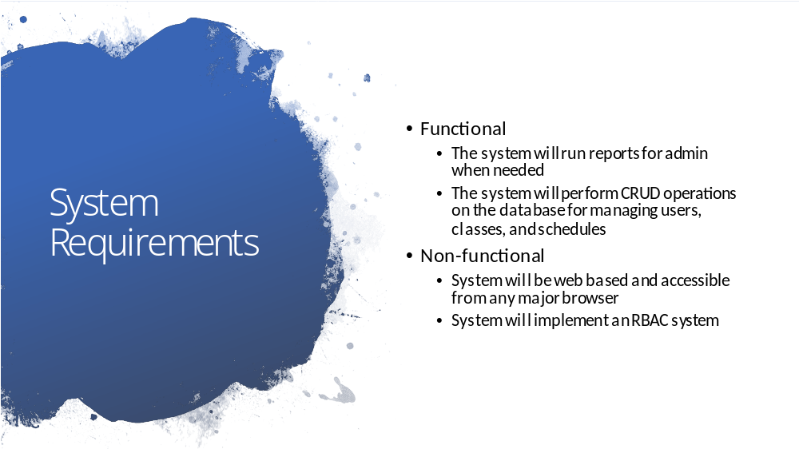

An administrator will need to see how the business is doing and when changes happen in the case of an error. We have implemented the ability to run reports on the system to assist in these scenarios.

The system manages itself by performing operations that automatically manage users, classes, and schedules. CRUD is an acronym that stands for “Create, Read, Update, Delete”. These actions have been exposed in an easy to use interface for the users in this system that will need them.

Our system is a web application. This means DriverPass will be accessible from any major browser. Anywhere in the world.
We take the security of DriverPass seriously. Each user will have access only where needed.

Slide 3

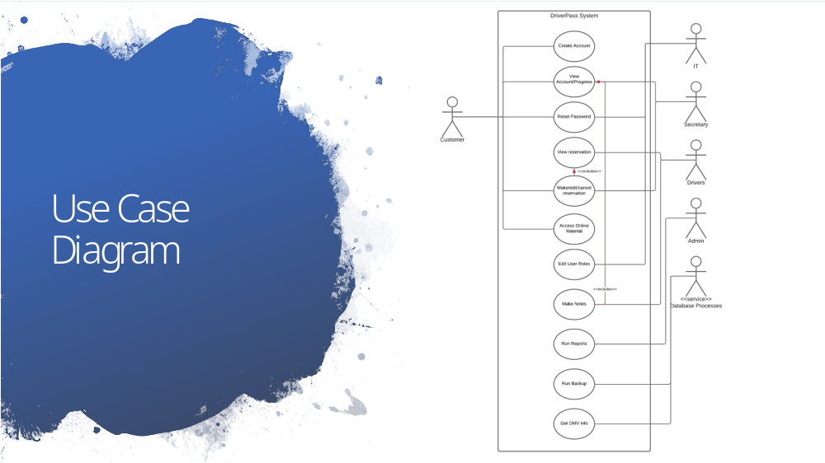

Here we see several ways in which our users can interact with our system. A student can create accounts, view their progress, reset their password, manage reservations with a driver, and of course, access their study materials.

IT can assist users with account problems, and assign other employees varying types of access.

Secretaries can help students manage reservations.

Admin can run reports

The system processes ensure a consistent experience every day.

Slide 4

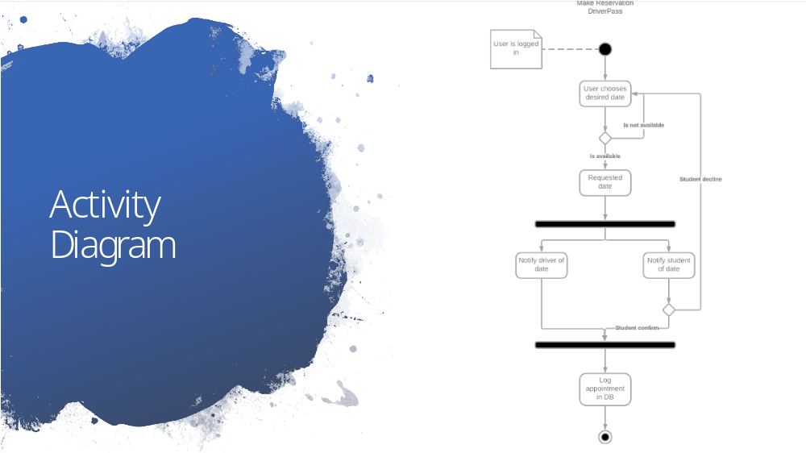

Here we can see how a student makes a reservation.

Once a student is logged in, they have access to this activity.

A student will request a date that he/she wishes to drive with an instructor. If the date is available, the instructor is notified, and the student will confirm the date. If the date is confirmed, the appointment is scheduled.

Slide 5

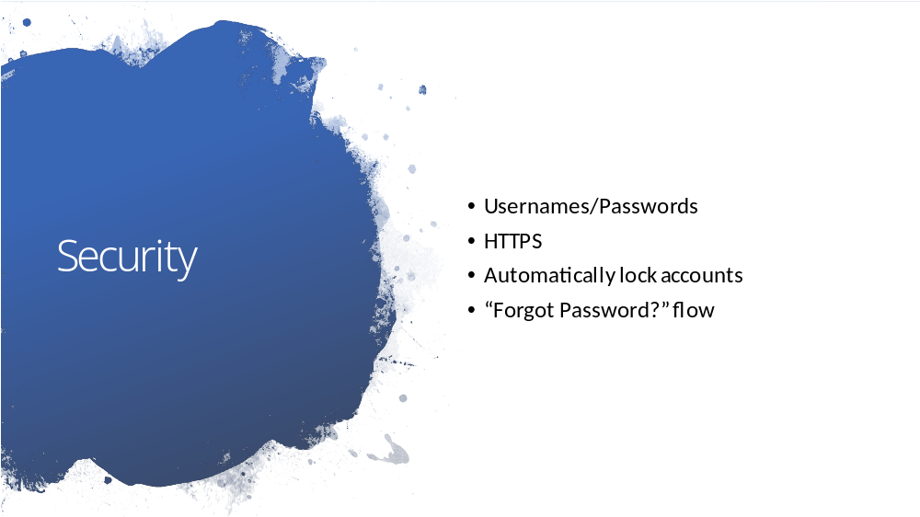

When securing our application, we wanted to ensure an experience that was consistent with other services available today so that users would have familiar use paradigms available to them.

We secure our system with username and passwords and when a browser speaks to our application, rest assured that the conversation is happening over a secure channel.

If a bad actor tries to access an account, we will automatically lock the account from logging in after 10 failed attempts. An email is then sent to the registered address with a link to unlock the account automatically without getting IT involved.

Should a user forget their password, he/she can reset it using the “Forgot Password?” button most of us are used to.

Slide 6

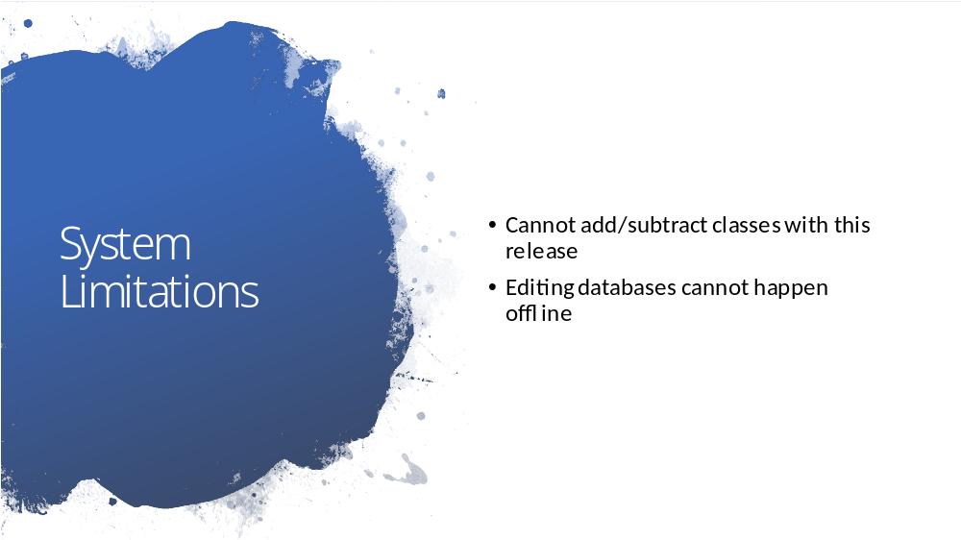

In our initial application the ability to add or remove classes will not be available by a non-developer role. In the future we plan to add this ability.

As discussed in our conversation, we will need to ensure that databases are not being edited while offline to avoid collisions.

